***Documentation***

**Title: Wiki Loves Monuments 2016**

**Project description:**

Wiki Loves Monuments is an international photography competition that encourages people to capture images of cultural heritage monuments. Held in Kosovo for the third time, this event aimed to collect freely licensed photos of historic buildings, monuments, and heritage sites to be used on Wikipedia. Participants submitted their photographs to Wikimedia Commons throughout September. The competition promoted cultural awareness and documentation, with winning entries from national contests advancing to an international level judged on technical quality, originality, and educational value. The 2016 event in Kosovo was supported by the Ministry of Culture, Youth, and Sports, the Kosovo Institute for the Protection of Monuments, and the Wikimedia Foundation.

**Activities:**Key activities:

* Organized promotional campaigns through the official website, social media, and local informational sessions.
* Held five informative sessions across seven cities in Kosovo.
* Provided guided tours of selected monuments for photographers.
* Coordinated the submission and evaluation process of 648 photographs from 38 photographers.
* Held a "Marathon Editathon" to write and improve articles using the submitted images.
* Organized a jury panel to select the best photographs for international submission.

**Photos:**

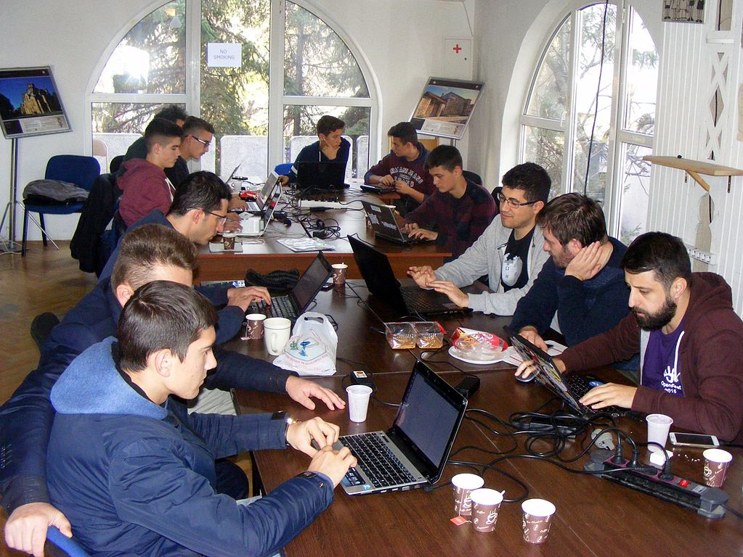

**Beneficiaries:**

The primary beneficiaries were photographers who participated in the competition, gaining international exposure for their work and contributing to the documentation of Kosovo's cultural heritage. Additionally, local institutions, including the Ministry of Culture and the Kosovo Institute for the Protection of Monuments, were beneficiaries by promoting cultural preservation and awareness. The general public, particularly Wikipedia users, benefited from the increased access to high-quality images for educational and cultural purposes.

**Partners:**

* Ministry of Culture, Youth, and Sports of Kosovo
* Kosovo Institute for the Protection of Monuments
* Wikimedia Foundation
* Open Labs

**Budget:  
€10,175.66**

**Project duration**:

September 1 – October 9, 2016

*This document is FLOSSK intellectual property - Do not share without authorization from FLOSSK.*